

**AMERICAN INTERNATIONAL UNIVERSITY–BANGLADESH (AIUB)**

**FACULTY OF SCIENCE & TECHNOLOGY**

**DEPARTMENT OF PHYSICS**

**PHYSICS LAB 2**

**Summer 2020-2021**

**Section: X, Group: 07**

**LAB REPORT ON**

***To determine the refractive index of the material of given prism using a spectrometer.***

**Supervised By**

**Dr. Md. Nurul Kabir Bhuiyan**

**Submitted By**

|  |  |  |
| --- | --- | --- |
| **Name** | **ID** | **Contribution** |
| **1. Md. Fahtin Emtiaz Onik** | **19-40471-1** | **Introduction, Discussion** |
| **2. Nafinur Leo** | **20-42195-1** | **Apparatus, Procedure** |
| **3. S.M. Ashikur Rahman** | **20-42833-1** | **Experimental Data Table** |
| **4. S.M. Hosney Arafat Rizon** | **20-43019-1** | **Result, Analysis** |
| **5. Rad Shahmat Sabit** | **20-43610-1** | **Calculation, References** |

Date of Submission: **July 11, 2021**

**TABLE OF CONTENTS**

|  |  |
| --- | --- |
| **TOPICS** | ***Page no*.** |
| **i) Title Page** | 1 |
| **ii) Table of Content** | 2 |
| 1. **Introduction** | 3 |
| 1. **Apparatus** | 4 |
| 1. **Procedure** | 5 |
| 1. **Experimental Data** | 7 |
| 1. **Analysis and Calculation** | 8 |
| 1. **Result** | 8 |
| 1. **Discussion** 2. **References** | 8  8 |
|  |  |
|  |  |

**1. Introduction**

When a beam of light strikes on the surface of transparent material (glass, water, quartz crystal, etc.), the portion of the light is transmitted and other portion is reflected. The transmitted light ray has small deviation of the path from the incident angle. This is called refraction.

Refraction is due to the change in speed of light while passing through the medium. It is given by Snell's law,

$\frac{\sin\left(i_{1}\right)}{\sin\left(r_{1}\right)}$ = $\frac{n_{2}}{n_{1}}$, (1)

Where i is the angle of incident, r is the angle of refraction, n1 is the refractive index of the first medium and n2 is the refractive index of the second medium.

When a ray of light passes through a prism, it suffers refraction as shown in fig. 1.

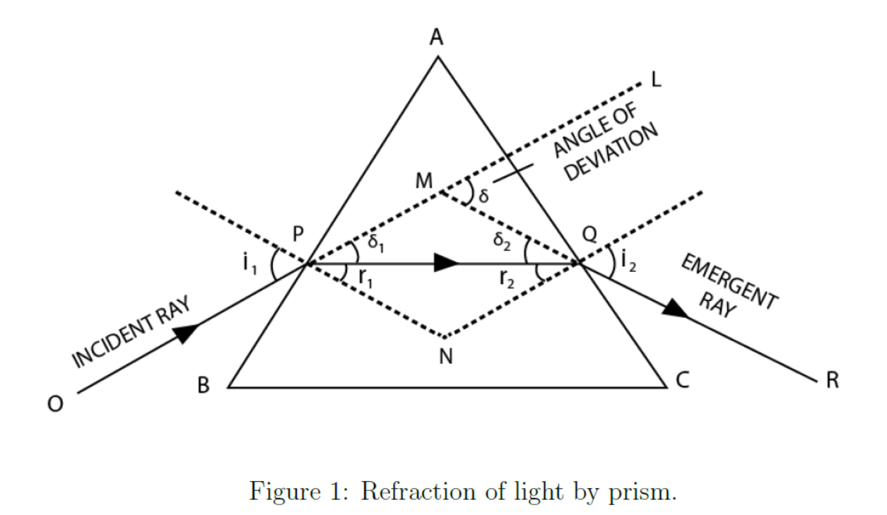

We can apply Snell’s Law to the ray of light at each surface. This leads to the two equations,

$\sin{i_{1}}=n\sin{r_{1}}$ (2)

$\operatorname{nsin}{r_{2}}=\sin{i_{2}}$ (3)

The angle r1 and r2 are not independent, being related by the equation,

$A= r_{1}+r_{2}$ (4)

Where A is angle of prism.

Applying the exterior angle theorem we get,

δ = (*i*1 − *r*1) + (*i*2 − *r*2) (5)

Combining eq. (4) and (5), we have

δ = *i*1 + *i*2 – *A* (6)

Solving eq. (2) and (3) for *i*1 and *i*2, respectively, we get

$i_{1}=sin^{-1}(n\sin{r_{1})}$ (7)

$i_{2}=sin^{-1}(n\sin{(A-r_{1}))}$ (8)

Finally, substituting these two equations into eq. (6) we get,

$δ=sin^{-1}(n\sin{r_{1})+sin^{-1}\left(n\sin\left(A-r_{1}\right)\right)-}A$ (9)

In minimum deviation position,

∠*i*1 = ∠*i*2 and so ∠*r*1 = ∠*r*2 = ∠*r* or

(10)

Then from eq. (6) we have,

2 =  (11)

Substituting this into eq. (3) and solving for the index of refraction gives,

$n=\frac{ {sin⁡((δm + A) }/2)}{sin⁡(A/2)}$ (12)

The angle δm is known as the minimum angle of deviation for the prism at the wavelength λ.

**2. Apparatus**

(1) A spectrometer

(2) A spirit level

(3) A source of monochromatic light (sodium vapour lamp)

(4) A glass prism

(5) A magnifying lens and

(6) A reading lamp

**3. Procedure**

**(A) Telescope adjustment:**

(1) We were arranged the spectrometer and the prism table was in horizontal position by using the leveling screws. (As shown in fig. 2)

(2) Then the telescope was turned towards a distant object to receive a clear and sharp image.

(3) The slit was illuminated by a sodium vapour lamp and the slit and the collimator are suitably adjusted to receive a narrow, vertical image of the slit.

(4) After that, the telescope was turned to receive the direct ray, so that the vertical slit coincides with the vertical crosswire.

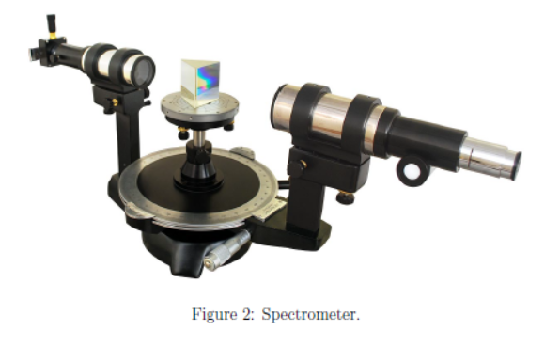

**(B) Measurement of the angle of the prism:**

(1) The least count of the spectrometer was determined by us.

(2) After that, the prism on the prism table with its refracting angle a towards the collimator and with its refracting edge a at the center was placed by us. In this case some of the light falling on each face will be reflected and can be received with the help of the telescope. (As shown in fig. 3).

(3) The telescope was moved to one side to receive the light reflected from the face AB by us and the cross wires were focused on the image of the slit. We took readings of the two verniers.

(4) Again the telescope was moved in other side to receive the light reflected from the face AC and again the cross wires were focused on the image of the slit. We took the verniers reading again.

(5) The angle through which the telescope was moved; or the deference in the two positions gave twice of the refracting angle A of the prism. Therefore half of this angle gave the refracting angle of the prism.

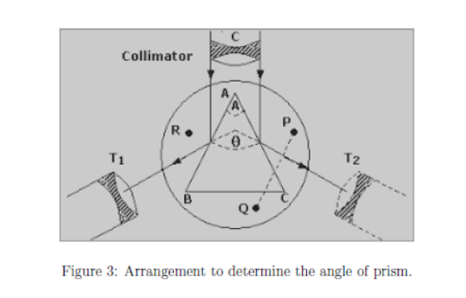

**(C) Measurement of the angle of minimum deviation:**

(1) The prism was placed by us so that its center coincided with the center of the prism table and light falls on one of the polished faces and emerges out of the other polished face, after refraction. Then the telescope was turned by us to view the refracted image of the slit on the other face (as shown in fig. 4).

(2) The vernier table was turned carefully and slowly in such a direction that the image of slit is move directed towards the directed ray, in the direction of decreasing angle of deviation.

(3) It was found that at a certain position, the image is stationary for some moment. Vernier table was fixed at the position where the image remains stationary. Using telescope fine adjusting slider, we made coincide the slit with cross wire.

(4) The corresponding main scale and vernier scale reading in both vernier was noted down (vernier I and vernier II).

(5) The prism from the prism table was removed carefully by us. The telescope was turned parallel to collimator, and noted the direct ray readings.

(6) Finally, the difference between the direct ray readings and deviated readings was found by us. This angle is called angle of minimum deviation (δm). Therefore, we have to calculate the refractive index of the material of the prism is determined by using eq. (12).

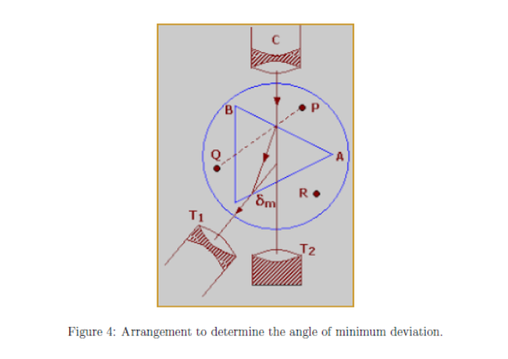

**4. Experimental Data**

**Table 1: Angle of minimum deviation (δm)**

|  |  |  |  |  |  |  |  |  |  |  |  |
| --- | --- | --- | --- | --- | --- | --- | --- | --- | --- | --- | --- |
| **Vernier Number** | **No. of Observation** | **Readings for minimum deviation position** | | | | **Readings for Direct position** | | | | **Angle of minimum dev.**  **δm = M ~ N** | **Mean δm** |
| **Main scale readings (s)** | **Vernier scale division** | **Vernier scale reading v = vd x vc** | **Total**  **M = S + V** | **Main scale reading(s)** | **Vernier scale division** | **Vernier scale reading v = vd x vc** | **Total**  **N = S + V** |
| i. | 1 | 350 | 6 | 0.1 | 350.1 | 391 | 8 | 0.13 | 391.13 | 41.03 | 41.20 |
| 2 | 71 | 15 | 0.25 | 71.25 | 30 | 10 | 0.17 | 30.17 | 41.08 |
| 3 | 354 | 4 | 0.07 | 354.07 | 398 | 5 | 0.08 | 398.08 | 44.01 |
| ii. | 1 | 169 | 2 | 0.033 | 169.03 | 211 | 10 | 0.17 | 211.17 | 42.14 |
| 2 | 249 | 10 | 0.17 | 249.17 | 209 | 13 | 0.22 | 209.22 | 39.95 |
| 3 | 174 | 12 | 0.2 | 174.02 | 213 | 2 | 0.03 | 213.03 | 39.01 |

**5. Analysis and Calculation**

**Calculating the value of refractive index:**

$$n=\frac{sin⁡( \frac{δ_{m}+A}{2} )}{sin⁡( \frac{A}{2} )}=\frac{sin⁡( \frac{41.20+60}{2} )}{sin⁡( \frac{60}{2} )}=1.55$$

**Least count of spectrometer:**

One main scale division, N = 1 degrees

No. of divisions on vernier, v = 60

Least count = $\frac{N}{v}= \frac{1}{60}$ = 0.0167 degrees

**6. Result**

(1) Angle of prism: 60 degrees

(2) Angle of minimum deviation of the prism: 41.20 degrees

(3) Refractive index of the material of the prism: 1.55

(4) Percentage of error: $\frac{nth-nex}{nth}*100=\frac{1.51-1.55}{1.51}*100=0.0263*100=2.63 \%$

**7. Discussion**

The purpose of this experiment is to determine the refractive index of the material of given prism using a spectrometer. The refractive index value is 1.55. So, we can say that it’s crown type glass.

(1) Refractive index of the material of the prism 1.55 and theoretical value 1.51

(2) Percentage of error of reflective index 2.63%

(3) We were careful at the time of leveling screws.

(4) We adjusted sodium vapour lamp and the slit and the collimator suitably for receiving a proper image of slit.

(5) We tried our best to take the proper readings for make data table.

(6) We carefully calculated the reflective index.

(7) We tried to avoid errors, though we get 2.63% error on reflective index.

**8. References**

*(i) Fundamental of physics: Resnick & Halliday*

*(ii) Practical physics: R. K. Shukla, Anchal Srivastava, New Age International (p) ltd,New Delhi*

*(iii) Zemansky, M.W. (1968) Heat and Thermodynamics*